Value Chain Impact Assessment

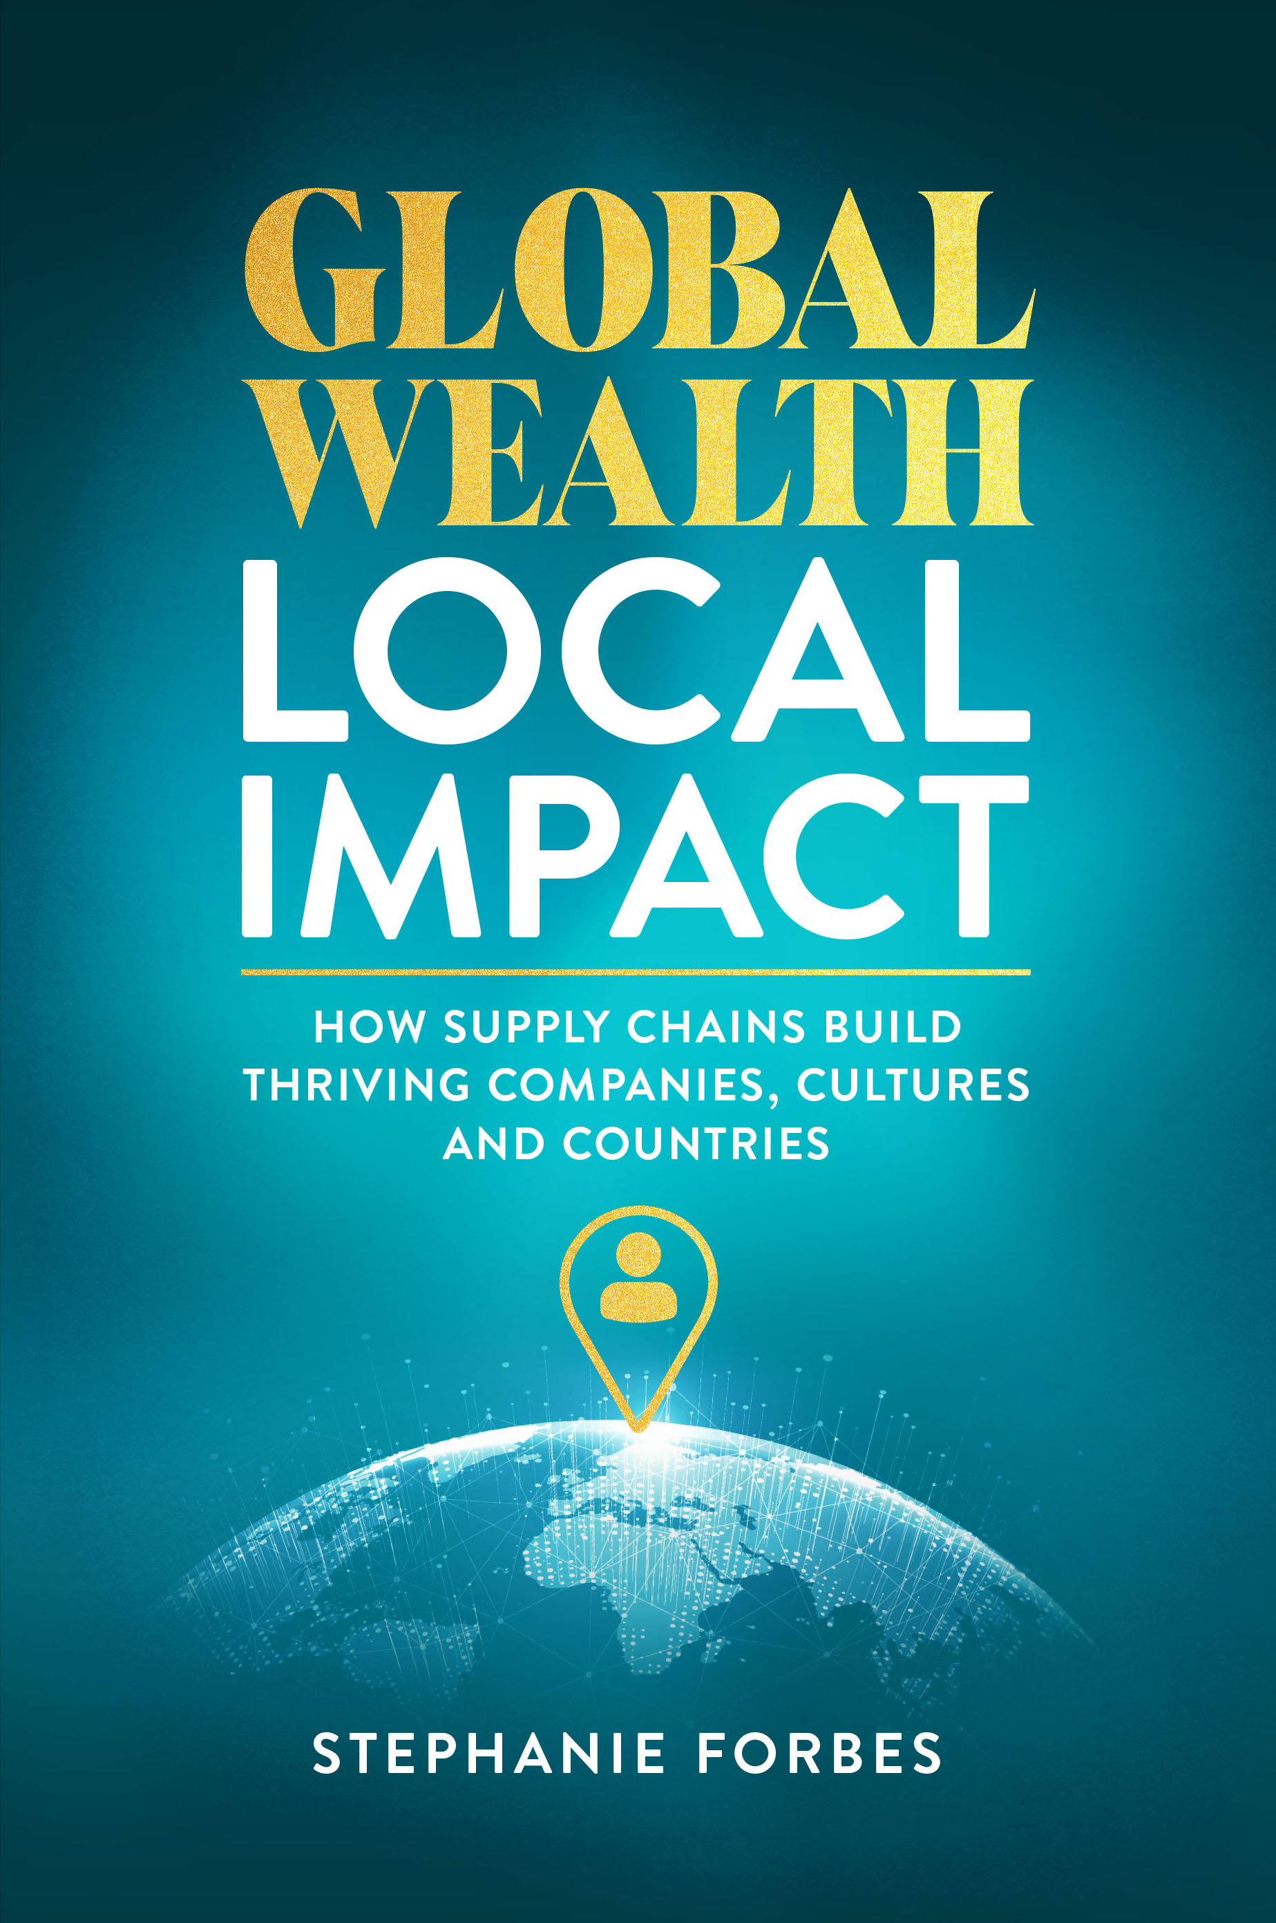

Value Chain Impact Assessment
This assessment helps you evaluate how your organization—or team—or you—performs across the seven pillars explored in Global Wealth, Local Impact: How Value Chains Build Thriving Companies, Cultures, and Countries. Every business operates somewhere along a value-chain maturity curve. Wherever you are, this tool helps you pinpoint your position and identify practical next steps to strengthen performance, resilience, and alignment.
Each section represents one of the seven key pillars of organizational value creation:
1. Tactical Execution
2. Strategic Alignment
3. Negotiation
4. Partnerships & Alliances
5. Metrics & Measurement
6. Inflation & Economics
7. Global Impacts
How to Use This Workbook:
1. Read each statement carefully.
2. Rate your organization on a scale from 1 to 5.
3. Add up your total for the section.
4. Review your score interpretation and use the action steps to guide improvement.
Scoring Scale (for each statement):
1 | Rarely true
2 | Occasionally true
3 | Sometimes true
4 | Often true
5 | Consistently true

Section 1: Tactical Mastery
Tactics are where ideas meet execution. Strong tactical performance turns strategic intent into measurable results. When discipline and clarity guide daily actions, organizations build momentum and resilience—even in volatile markets.
Rate each statement from 1 (Rarely true) to 5 (Consistently true). Record your score in the right column.
# | Statement | Your Score (1–5)
1 | Daily priorities are clear, communicated, and linked to overall objectives.
2 | Standard operating procedures are documented, visible, and followed.
3 | Teams adapt quickly to disruptions without losing focus or accountability.
4 | Roles, responsibilities, and decision-making authority are clearly defined.
5 | Lessons learned from projects are captured, shared, and applied.
Your Total (sum of your five scores): ______ / 25

Interpret Your Score
Total Score | Level | What It Means
5–10 | Ad Hoc Execution | Success depends on individuals, not systems. Begin by standardizing critical processes.
11–15 | Structured but Inconsistent | Some rhythm exists, but results vary. Focus on developing or updating processes and workflows.
16–20 | Operationally Sound | A disciplined foundation is in place; continue refining speed, cross functional collaboration and coordination.
21–25 | Execution Excellence | Execution is your advantage. Maintain rigor and evolve continuously.

Action Steps / From the Book
• Revisit Chapter 1: Tactical Mastery for execution frameworks.
• Define what 'done right' looks like for recurring processes.
• Establish short feedback loops after every major deliverable.

Section 2: Strategic Alignment
Strategy is a living system of choices that connects vision to action. Alignment ensures those choices cascade clearly from the boardroom to the front line, building agility and coherence.
Rate each statement from 1 (Rarely true) to 5 (Consistently true). Record your score in the right column.
# | Statement | Your Score (1–5)
1 | The organization has a clear, communicated strategic direction understood at all levels.
2 | Departmental and team goals are directly linked to strategic objectives.
3 | Leaders evaluate external trends and adapt strategies accordingly.
4 | Decisions about resources and priorities align with long-term goals.
5 | Strategy is reviewed and refined consistently, not just during annual planning.
Your Total (sum of your five scores): ______ / 25

Interpret Your Score
Total Score | Level | What It Means
5–10 | Disconnected Strategy | The vision exists on paper but not in execution. Translate goals into tangible actions.
11–15 | Aligned in Theory | Strategy is clear but inconsistently applied. Strengthen communication channels.
16–20 | Strategically Integrated | Direction and action align; fine-tune metrics and decision rights.
21–25 | Future-Ready Leadership | Strategy drives every choice with adaptability and clarity.

Action Steps / From the Book
• Revisit Chapter 2: Strategic Alignment for insights on foresight and adaptability.
• Audit communication flow—can every team link their objectives to strategy?
• Hold quarterly strategy-to-execution reviews.

Section 3: The Art of Negotiation
Negotiation isn’t a single moment—it’s a disciplined process of preparation and value creation. When treated as a repeatable system, negotiation protects value and builds lasting trust.
Rate each statement from 1 (Rarely true) to 5 (Consistently true). Record your score in the right column.
# | Statement | Your Score (1–5)
1 | Negotiations begin with clear objectives, data, and defined walk-away points.
2 | Preparation includes understanding the counterpart’s motivations and constraints.
3 | Outcomes balance value, risk, and long-term relationship health.
4 | Lessons from past negotiations are captured and revisited.
5 | Negotiation is treated as a strategic capability, not an ad-hoc skill.
Your Total (sum of your five scores): ______ / 25

Interpret Your Score
Total Score | Level | What It Means
5–10 | Transactional Negotiation | Deals rely on instinct or urgency. Start with structured preparation.
11–15 | Inconsistent Practice | Some negotiations are strategic, others reactive. Build templates and routines.
16–20 | Disciplined Negotiator | Negotiations are balanced and data-driven. Share knowledge internally and cross functionally.
21–25 | Strategic Value Creator | You negotiate with structure and empathy—creating enduring outcomes.

Action Steps / From the Book
• Revisit Chapter 3: The Art of Negotiation and Chapter 4: The Negotiation Playbook.
• Define non-negotiables and align them across departments.
• Track negotiation results—value saved, risk reduced, relationships maintained.

Section 4: Partnerships & Alliances
Strong partnerships are built on structure, trust, and mutual accountability. When governance and incentives align, collaboration becomes a force multiplier.
Rate each statement from 1 (Rarely true) to 5 (Consistently true). Record your score in the right column.
# | Statement | Your Score (1–5)
1 | Partnership goals and decision rights are clearly documented and understood.
2 | Incentives and risks are shared fairly and consistently across all parties.
3 | Regular communication and governance meetings maintain alignment.
4 | Partner performance is tracked with agreed-upon metrics.
5 | Partnerships are reviewed periodically to evolve or exit as needed.
Your Total (sum of your five scores): ______ / 25

Interpret Your Score
Total Score | Level | What It Means
5–10 | Loose Collaborations | Partnerships rely on goodwill, not systems. Start defining objectives and roles.
11–15 | Functional but Fragile | Cooperation exists but lacks clear systems and processes. Improve visibility and incentives.
16–20 | Structured Alliances | Roles and rewards are balanced; refine transparency and reviews.
21–25 | Strategic Partnerships | Partnerships extend reach and innovation with measurable value.

Action Steps / From the Book
• Revisit Chapter 5: Partnerships & Alliances for frameworks on shared accountability.
• Map partnerships and identify gaps in clarity or incentive alignment.
• Use a simple partner scorecard for financial and operational metrics.

Section 5: Metrics & Measurement
What gets measured gets managed—but only if it’s the right thing. Effective metrics focus on outcomes, not optics, turning data into actionable insight.
Rate each statement from 1 (Rarely true) to 5 (Consistently true). Record your score in the right column.
# | Statement | Your Score (1–5)
1 | Key metrics link directly to organizational goals and value creation.
2 | Teams understand how their metrics contribute to success.
3 | Dashboards highlight insights and actions, not vanity statistics.
4 | Metrics evolve as business priorities change.
5 | Data quality and accountability are well-governed across teams.
Your Total (sum of your five scores): ______ / 25

Interpret Your Score
Total Score | Level | What It Means
5–10 | Data Without Direction | You collect data but lack insight. Define decisions your metrics support.
11–15 | Metrics in Motion | Some useful data exists, but ownership and consistency vary.
16–20 | Performance-Focused | Measurement drives accountability and learning.
21–25 | Insight-Driven Organization | Metrics align perfectly with strategy and improvement cycles.

Action Steps / From the Book
• Revisit Chapter 6: Metrics & Measurement for guidance on meaningful indicators.
• Audit reports—eliminate vanity metrics and focus on drivers of value.
• Assign owners for each key metric to ensure accountability.

Section 6: Inflation & Economics
Economic pressure exposes the strength of your value chain. Understanding costs, contracts, and market signals turns volatility into foresight.
Rate each statement from 1 (Rarely true) to 5 (Consistently true). Record your score in the right column.
# | Statement | Your Score (1–5)
1 | The organization understands key cost drivers and market sensitivities.
2 | Financial planning models account for inflation and interest-rate scenarios.
3 | Contracts include clauses to manage volatility (e.g., escalation, hedging).
4 | Leaders review economic indicators and adjust forecasts accordingly.
5 | Cost management decisions balance short-term savings with long-term positioning.
Your Total (sum of your five scores): ______ / 25

Interpret Your Score
Total Score | Level | What It Means
5–10 | Reactive to Market Forces | Inflation drives you. Start tracking key costs and indicators.
11–15 | Operational Awareness | You track costs but lack integrated planning. Build forecasting discipline.
16–20 | Financially Agile | You adapt well to shifts. Refine resilience and cross-functional visibility.
21–25 | Economically Strategic | Volatility is managed proactively. You lead through uncertainty.

Action Steps / From the Book
• Revisit Chapter 7: Inflation & Economics for frameworks on cost resilience.
• Map your top cost drivers and model 5–10% swings.
• Include economic scenario reviews in leadership meetings.

Section 7: Global Impacts
Global shifts—trade, regulation, environment—shape local performance. Understanding and anticipating them builds lasting advantage.
Rate each statement from 1 (Rarely true) to 5 (Consistently true). Record your score in the right column.
# | Statement | Your Score (1–5)
1 | The organization monitors geopolitical and trade developments.
2 | Sourcing strategies include geographic diversity and contingency planning.
3 | Leadership integrates global risk analysis into decision-making.
4 | Teams understand how global events affect local operations.
5 | Global awareness is treated as a competitive capability, not a compliance task.
Your Total (sum of your five scores): ______ / 25

Interpret Your Score
Total Score | Level | What It Means
5–10 | Locally Focused | Global events surprise you. Build awareness and monitoring systems.
11–15 | Regionally Aware | Some global risks recognized; contingency planning limited.
16–20 | Globally Responsive | You react effectively to emerging risks. Strengthen scenario planning.
21–25 | Globally Strategic | You anticipate and capitalize on change. Global insight is your edge.

Action Steps / From the Book
• Revisit Chapter 7: Global Impacts for guidance on global resilience.
• Map your end-to-end value chain and concentration risks.
• Create a quarterly ‘geo scan’ to track trade, logistics, and regulation.

Your Results: The Value Chain Readiness Index
Add up your total points from all seven sections to determine your organization’s Value Chain Readiness level.
Total Score | Level | What It Means
70–99 | Foundational Awareness | You’re building structure but still operating in silos.
100–129 | Developing Systems | Frameworks exist, but processes, systems and execution varies.
130–154 | Integrated & Resilient | Strategy and operations are connected.
155–175 | Best-In-Class Value Chain | You operate with discipline, agility, and foresight.
Your score isn’t an endpoint—it’s a benchmark for progress. Use it to identify focus areas, align teams, and revisit the relevant chapters in Global Wealth, Local Impact to strengthen your organization’s value chain maturity.

Next Step: Strengthen Your Value Chain
Completing this assessment is the first step toward building a more resilient, high-performing organization. The next step is action.
If you’d like to discuss your results, uncover areas of untapped value, or explore how your organization can enhance performance across its value chain, I offer a complimentary consulting call for teams and leaders.
Together, we can:
- Review your assessment results and identify your organization’s biggest opportunities.
- Map short-term wins and long-term improvements tailored to your goals.
- Align people, processes, and systems for measurable, lasting impact.
Let’s turn insight into advantage.
📞 Book a Free Value Chain Consultation
Email: stephanie@theforbesgroup.ca
Website: www.theforbesgroup.ca
LinkedIn: LinkedIn

